# **Created By Erum Sikander**

# **Hackathone-3 Day 2**

**My Introduction:**

My name is “Erum Sikander” I am from Hyderabad and I am a Student of the Sunday 2 to 5 pm Sir Ali Jawad Is my teacher and I am also a Senior Student…!

**Online Shopping Website:**

This project is a fully functional e-commerce website designed to provide a seamless shopping experience for users. The website integrates multiple features, such as product browsing, special offers, user authentication, and an easy-to-use checkout system. Below is a detailed description of the key sections and functionalities included in the website.

### **1. Homepage Layout and Navigation**

The homepage serves as the central hub for users to explore the store’s offerings. The navigation bar includes:

* A **search bar** for users to find products easily.
* A prominent banner showcasing seasonal promotions, such as "50% off on select items."
* Quick links to explore the best sellers and newly added items.

### **2. Product Categories**

The homepage highlights various product categories:

* **Bags for Women:** A selection of stylish handbags and purses tailored to women.
* **Winter Collection:** Clothing and accessories designed for the colder season.
* **Sandals for Women:** Trendy and comfortable footwear options.
* **Protect Your Eyes:** A collection of sunglasses to keep your eyes safe in style.

### **3. Step-by-Step Shopping Process**

The website simplifies the shopping journey into three clear steps:

1. **Find Your Favorite:** Users can browse a wide variety of high-quality products tailored to their preferences.
2. **Customize Your Order:** Customers can personalize or select product options as needed.
3. **Place Your Order:** With an optimized checkout flow, users can quickly finalize their purchases

### **4. Featured Products Section**

The homepage also features a section displaying the latest arrivals with product cards, such as:

* A **camera** priced at 2000.00.
* A high-quality **headphone** also priced at 2000.00.
* A sleek **laptop** available for the same price.

### **5. Exclusive Offers and Deals**

The "Special Offers" section is prominently displayed to attract customer attention. Deals include:

* **Happy Shopping:** Buy one, get one free on select items.
* **Home Appliances:** Discounts for purchasing multiple products.
* **Shoes Offer:** Another buy-one-get-one-free promotion.

### **6. User Authentication**

The website includes a login and sign-up modal that enables users to:

* Log in with an email and password.
* Sign in conveniently using Google authentication.

### **8. Visual Appeal and User Experience**

The website’s design is clean and modern, with:

* A dark-themed layout that makes images and text stand out.
* Clear typography and bold CTAs (Call to Actions) to guide users.
* High-quality images that enhance the overall aesthetic and user engagement.

### **9. Buy 1, Get 1 Free – Limited Time Only:**

Discover our exclusive collection, grab unbeatable deals, and shop now to save big….

### **10. Delivery Address Functionality:**

1. Full Name:
2. Phone Number:
3. Address:
4. City:
5. State:
6. Country:
7. Submit Button:

After filling out all required fields, users click the Submit button to save their delivery address and proceed to the next step...!

**For Example:**

* + **payment or order confirmation.**

**Checkout:**

* **Please confirm your order before proceeding.**

**Architecture Diagram Overview:**

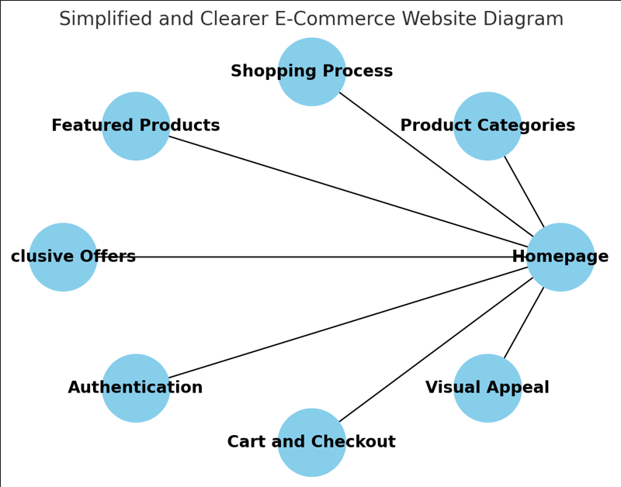

**API Endpoints Detail**

|  |  |  |  |  |
| --- | --- | --- | --- | --- |
| **Endpoint** | **Method** | **Description** | **Parameters** | **Response Example** |
| **/api/products** | **GET** | **Fetch all products** | **None** | **{id: 1, name: “Laptop”, price: 2000.00}** |
| **/api/products/:id** | **GET** | **Fetch a single product** | **id (Path)** | **{id: 1, name: “Laptop”, price: 2000.00}** |
| **/api/products** | **POST** | **Add a new product** | **name, price, category (Body)** | **{success: true, id: 5}** |

### **Conclusion**

This e-commerce website effectively combines functionality, aesthetics, and user-centric design. From product browsing to checkout, every feature is optimized to provide a hassle-free shopping experience. The integration of promotional offers, a responsive layout, and secure user authentication make this project a standout solution for online retail businesses…!

Building this **e-commerce website** was a big challenge for me. At first, I didn’t know where to start, and everything felt confusing. But once I began, I faced many errors and obstacles along the way. With hard work, sleepless nights, and continuous effort, I managed to fix everything and finally complete my website. I’m deeply grateful to **all my teachers**, especially **Sir Ameen Alam**, **Sir Ali Jawad**, **Miss Nida**, **Sir Sami**, and all the faculty members. Thank you for giving me the chance to learn and for guiding me through this journey. This project taught me so much, and because of your support, **I can now proudly call myself a Frontend Developer** my name is **Erum Sikander**, a senior student of the **Sunday 2 to 5 PM class**. Thank you for everything!

**Thank you…!**

**“Sir Ameen Alam and my all teachers”**

**Erum Sikander**

**Your Obedient Student**